**MUHAMMAD NAQIUDDIN BIN MOHD NORDIN**

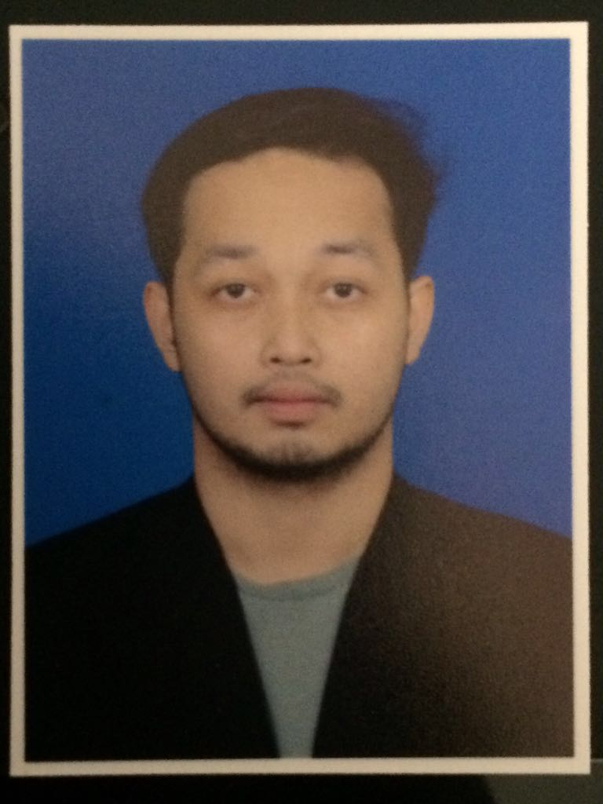

Lot 10090,

Jalan Kampung Air,

Mak Chili,

24000 Kemaman,

Terengganu.

Handphone No : 018 - 9093899

Home Phone No : 018 - 9093900

Email Address : naqiuddinnordin@hotmail.com

**Objective**

To obtain a full time position in a company which offers a professional working environment and enables me as an engineer to grow while meeting the corporation’s goals.

**PERSONAL DETAILS:**

Name : Muhammad Naqiuddin bin Mohd Nordin

Date of Birth : 30th January 1994

Age : 23

Gender : Male

Nationality : Malaysian

IC Number : 940130-11-5181

**EDUCATIONAL BACKGROUND:**

Universiti Tenaga Nasional (UNITEN), Selangor

Qualification : Bachelor Degree

Field of Study : Electrical Power Engineering

CGPA : 2.86 (current CGPA)

Graduation Date : December 2017 (expected)

Others

2007-2011 : Sekolah Menengah Kebangsaan Dato’ Abdul Razak

PMR : 8A’s

SPM : 8A+, 1B+

MUET Band Achieved : 3

**LANGUAGES :** **(0 = Poor , 10 = Excellent)**

(Proficiency 0=poor – 10=excellent)

**Languages Spoken Written**

Bahasa Melayu 10 10

English 8 8

**ACQUIRED SKILLS AND STRENGTH:**

Skills : Autocad, MATLAB, MPLAB, MS Visual Basic.Net, MS Visual C++,

Microsoft Office(Word, Excel,PowerPoint).

Strengths : Have high sense of responsibility, highly motivated, a team player and quick to learn with good interpersonal and organizational skill. A

hardworking person, able to work under considerable pressure and

organized in works.

Possesses own transport : Yes

Willing to travel : Yes

**EXTRA CO-CURRICULAR ACTIVITIES:**

* Project Manager of Fun Run 2013
* Facilitator of YTN CSR Program – UNITEN ke Sekolah 2014
* Facilitator of Foundation CSR Program – Pusat Jagaan Siti Nor Aini 2013
* Participant of Adobe Photoshop Workshop
* Participant of UNITEN Cup 2013-2014
* Participant of Langkah Ceria Teknologi Hijau KETTHA
* Participant of SEMBANG SISWA (SEMSIS 1)
* Participant of Rev Up Walking Dead
* Participant of Kin Ball League
* Participant of Youth Fest 2014

**RELEVANT COURSES TAKEN**

|  |  |
| --- | --- |
|  |  |
| 1st Year | Circuit analysis 1, Advance calculus, Differential equation, Circuit analysis 2, Digital logic design, Statics |
| 2nd Year | Signal and system, Electronic analysis and design, Linear algebra, Technical communication, Numerical method, Electromagnetic Field & waves, Electrical machines & drives, Thermodynamics 1 |
| 3rd Year | Control system 1, Microprocessor system, Power system 1, Communication system, Data communication and network, Digital signal & processor, Semiconductor devices, Random process |
|  |  |

**REFERENCES**

Mrs. Chen Chai Phing

Department of Electrical Power Engineering

Industrial Training Coordinator

University Tenaga Nasional Putrajaya Campus

Jalan IKHRAM-UNITEN

43000 Kajang, Selangor

Chencp@uniten.edu.my

03-8921 6646